Meeting log for Team: Singh-Bhawandeep Sp26-1
- Team Meeting with Advisor [1-28-26]
Absent: none
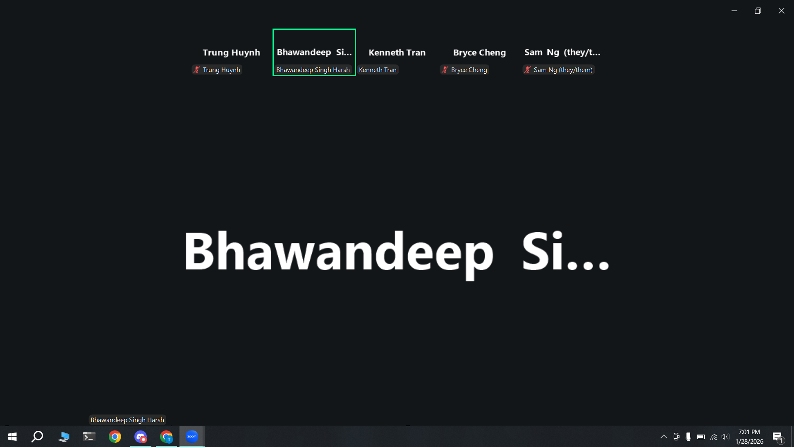
- We can pick either Janitorial Robot or Self balancing inverting pendulum robot (Integrated with Zybo and reinforcement learning).
- We can discuss with Dan Harkey to get his opinion on which idea would be more aligned with CMPE 295A/B.
- Professor Harsh stated that implementing the pendulum with a Zybo is complex, but to add reinforcement learning to find the parameters of the pendulum instead of manually calculating it with Matlab.
- The goal for this semester is to have Requirements, Architecture, and Design documents completed.
- A minimal prototype can be produced, but is not needed. The main goal is to have our requirements, architecture, and design documents frozen, so in CMPE 295B can be purely focused on execution and coding.
- Professor Harsh recommended the first month to be a literature review of our project to get knowledge on what the current state of the art is and to start thinking about the project scope.
- Have a google drive that he has access to, so he can be up to date with our progress such as data/requirements/architecture/design documents.
- Team Meeting [2-2-26]
Absent: none
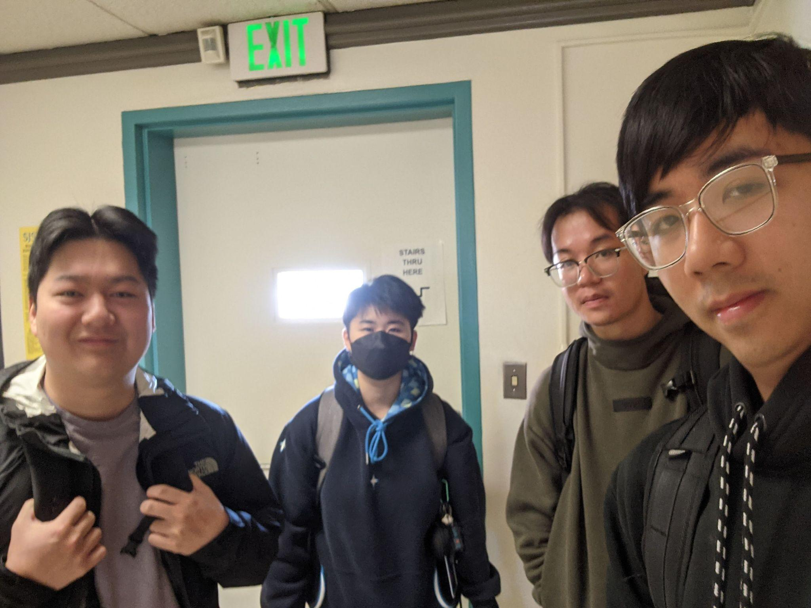
- We began finalizing our project topic and delegated who would be working on the abstract and presentation.
- Team Meeting [2-16-26]
Absent: none
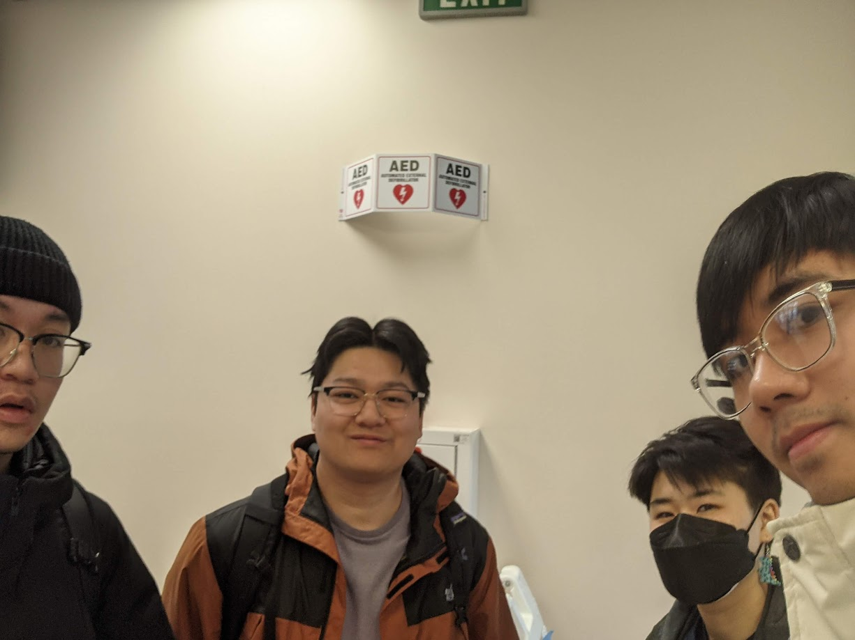
- We discussed the online meeting times this week, what questions we will ask our advisor on Wednesday, and our progress on the workbook.
- Team Meeting with Advisor [2-18-26]
Absent: none
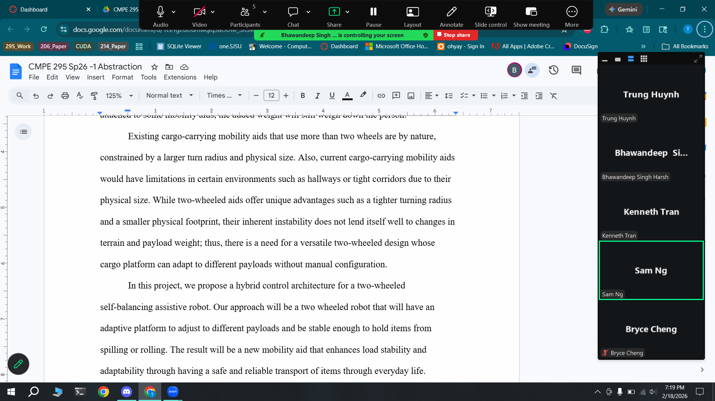
- We reviewed our abstract and discussed our reasons for a two-wheeled design as opposed to a three or four wheels and considered how its platform would be positioned relative to the ground.
- The Zybo Z7, the development board we plan to use, has 2 cores that we delegate: one core for balancing and one core for obstacle detection/tracking. Any peripherals we want to add will be connected via Pmod ports using I2C/SPI protocols.
- The reinforcement learning algorithm and training is planned to be done in the Zybo. The core should run at the same frequency during training and during deployment.
- For the robot to follow its user, the user will need to be carrying a transceiver while the robot will have 3 transceivers to triangulate the user and determine a path to reach them.
- The robot’s design should be versatile, supporting a platform that can act as a tray while also providing ways to attach bags/boxes/buckets for the user’s needs.
- Our next steps are to write up a separate project requirements document that can be later added to the workbook for submission.

